**MamaMia**

# ACKNOWLEDGEMENT

It gives me immense pleasure to present you to this MAMAMIA. We were lucky to get enormous support from extremely talented people, who deserve our great gratitude.

Firstly, we would like to thank our teacher and guide, **Prof.Lavkush** who gave his valuable suggestions and ideas whenever we needed them. Also, he encouraged us to work on this project tirelessly by giving us numerous consultations.

We are also grateful to our parents for their constant support, guidance and providing us the necessary resources for the project.

Lastly, we would like to thank our classmates for their valuable suggestions for the betterment of this project and everybody who has helped us directly or indirectly in completion of this project.

We are immensely grateful to everyone involved in this project a without their inspiration and valuable suggestion it would not have been possible to develop the project within the prescribed time.

With sincere thanks,

Ravina (21075570089)

Bhoomi Priya (21075570021)

Divya Pahwa(21075570027)

Tanya Maryam(2107550122)

Shristi Jain(21075570112)

# CERTIFICATE

This is to certify that the project entitled, “**MAMAMIA**”, has been submitted by Ravina, Bhoomi Priya, Divya pahwa, Shristi Jain and Tanya Maryam in partial fulfillment of the requirements of Bachelor of Computer Science(Hons.) embodies the work done by them during, semester IV of their course under the supervision of **Prof.Lavkush** Department of Computer Science, Shyama prasad Mukherji College for Women, University of Delhi

**TABLE OF CONTENTS**

1. Problem Statement…………………………… 8
2. Process Model………………………………….. 9-10
3. Requirement Analysis………………………. 12-23
   1. Use cases
      1. Use Case Description……………….
      2. Use case Diagram……………………
   2. Prototypes 24-29

3.3 DFD 29-32

* + 1. Context Level Diagram………………..

3.3.2 Level 1 Diagram………………………….

3.3.3Level 2 Diagram………………………….

* 1. Sequence Diagram 41-50
  2. Data Dictionary 32-33
  3. Data Design Tables 33-41

1. Software Requirements Specification(SRS) 41-50
   1. Introduction
      1. Purpose……………………………
      2. Project Scope……………………
      3. Definitions, acronym and scope……………………
      4. Overview………………………….

4. 2 Product Perspective

4.2.1 User Interface

4.2.2 Hardware Interface

4.2.3 Software Interface

4.3 Specific Requirements

4.3.1 User Interface

4.3.2 Hardware Interface

4.3.3 Software Interface

4.3.4 Communication Interface

4.4 Functions

4.5 Performance Requirements

4.6 Software Design Constraints

4.7 Software System Attributes

4.7.1 Safety and Security Constraints

4.7.2 Usability

4..7.3 Reliability

4.7.4 Availability

4.7.5 Portability

5.Timeline Chart………………………..54-58

l

1. Function Point…………………………..59-74
2. Estimation using COCOMO Model…………………71-80
3. Risk Analysis…………………………………………81-88
4. Testing…………………………………………………………… 1-3

**PROJECT TITLE : MAMAMIA**

**1. PROBLEM STATEMENT**

Being a mother requires full-time dedication. It is not like you can push the pause button, act like you're not a mother, and your duties as a mother will vanish for the day. But You don't also have to consider being a mother as the end of your independence, though.

That’s why we bring you **MamaMia,** a software designed for young mothers, working mothers, mothers living alone, single mothers etc. The software is one stop solution for all your motherly needs. Be it vaccine schedules or sleep schedules , the software will track all the crucial requirements of your newborn. The software will also have a feature to contact doctors from the comfort of your home. The software will also alert you about potential disease your baby could have if you provide the related symptoms. The software will also have an sos option to inform the concerned authority in case of any mishappening. Hope it makes the life of all the supermoms a bit easier.

**2. Project Model**

Process Flow: describes how the framework activities and the actions and tasks that occur within each framework activity are organized with respect to sequence and time.

**For our project we are following the Parallel Process Flow.**

In Parallel Process flow developer executes one or more framework activities in parallel with other framework activities.

**The project we are developing has the need of becoming present time and contemporary since the wants and needs of mother differ from each other and making our software a one stop solution to all motherly needs is our topmost priority. So our software needs simultaneous planning, modelling and construction.**Process Model  
A process model provides a specific roadmap for software engineering work. It defines the flow of all activities, actions and tasks, the degree of iteration, the work products, and the organization of the work that must be done.

**Incremental Process Model:** This model is applied in situations when there is a need to provide a limited set of software functionality to users quickly and then refine and expand on that functionality in later software releases  
  
**As our project is in early state of construction, with limited requirements known and future updates on line, Incremental model seemed like a suitable option. Our software focuses on one basic goal, i.e., to aid and help all the mothers in the country. We know our target audience and their fundamental requirements. We have till now made our software in accordance to their requirements and issues. But with oncoming mothers and this new generation becoming parents, us as the developers will witness huge contrast in their needs. So, to cater their changing and developing requirements, incremental model is an ideal model to apply. In this project we provide limited functionalities and performance to the users, with the hope to update and refurbish the software with upcoming requirements the user provides.**

**As we are following incremental model for our project, our core product as of now is ready with a few shortcomings here and there which we are working on currently. With adequate research and surveys, a plan will developed for the next increment.** 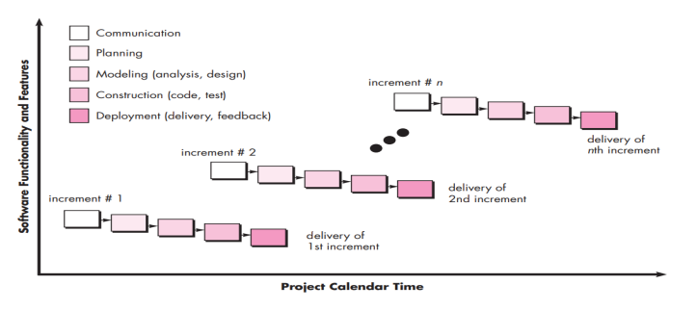

**3. REQUIREMENT ANALYSIS**

3.1 USE CASES:

3.1.1 USE CASE DESCRIPTION

**Actors:**

1. User
2. Admin
3. Doctors

**1.Login**

This will provide a way for all the actors to access the software by putting in their credentials.

**2.Sign Up**

This will be the option given to actors if they are accessing the software for the first time. This option will take information needed from them, save it in the database and then help them get into their accounts.

**3. Membership**

This would be an optional way for users to approach and utilize premium services and benefits at a very minimal price. This would include many offers and discounts for the users on occasions like mother’s day, birthdays etc. They would also get discount on doctors visit etc.

**4.Update**

This option would help the actors to increase functionality of the software from time to time.

**5. Schedules/Reminder**

This would alert the user of the important vaccination appointments and doctor visits for their infant. User would have to set up a reminder first. Vaccines needed for the infant will already be incorporated in the software.

**6.Gynaecologist/Paediatrician/Dietician**

This would be one stop solution for the users to contact highly experienced doctors If their infant faces any issues. The consultancy can be done by the mothers from the comfort of their home. Mothers can also visit the clinic of the doctors using the contact information the software will provide.

**7. Symptoms**

The users can enter the symptoms their baby is experiencing and the software will return diseases and conditions in corresponding to those symptoms ins just few minutes.

**8. About**

Description and introduction of the software. Will tell the actors about the functionalities provided by the software.

1. **Contact**

It will contain the phone number and an email address of the admin. User can contact to get any requisite information or to clear any doubt.

1. **Logout**

Option to exit the website.

**USE CASES:**

**LOGIN**

* 1. **Introduction:** use case describe how a user log into website.
  2. **Actors :** 1. User

2. doctor

3. admin

1.3 **Pre Conditions** : actors must sign up to website in order to do login.

**1.4 Post Condition :** If the use case is successful, the actor is logged into the system. If not, the system state will remain unchanged.

**1.5 Basic Flow:** This use case start when actor wishes to login to the website.

(i) In this system requests the actor to enter his/her name and password.

(ii) The actor enters his/her name & password

(iii) System validates name & password, and if finds correct allow the actor to logs into the system else not.

**1.6 Alternate Flow**:

**1.6.1 Invalid name & password** :If the actor enters an invalid name and/or password, the system displays an error message. The actor can choose to either return to the beginning of the basic flow or cancel the login, at that point, the use case ends.

**1.7 Special Requirements**: None

**1.8 Use case Relationships**: None

**2. SIGNUP**

**2.1 Introduction:** This option will given to user if they are using the software first , they have to provide some necessary data.

**2.2 Actors :** user, doctor

**2.3 Pre-Condition**: None

**2.4 Post-Condition** : if the use case is successful than actor can login to website and use it.

**2.5 Basic Flow:** Use case start whenever actor wish to.

(i). user have to provide details like name(first name and last name both), , phone number and email.

(ii). We verify the user phone number and email id.

(iii). User have to create password.

**2.6 Alternative flow:** display the error message if the user phone number or email verification is not successful.

Also if entered email id or phone number is already registered than user must signup with the new one.

**2.7 Special Requirement:** none

**2.8 Use case relationship:** none

**3.MEMBERSHIP**

**3.1 Introduction:** the user will get many offers and discounts on the occasion like mother’s day, child birthday etc.

**3.2 Actors:** user

**3.3 Preconditions**: In order to get the membership of mama mia user must signup the website and should have an account. To avail the membership, users will have to pay a minimal amount as well

**3.4 Post condition:** If user has successfully applied for membership then she/he will enjoy the premium services and benefits at the minimal prices. They can also get discount on doctor visit.

**3.5 Basic flow:**  The user will have a option to avail the membership on the software.

1. Once clicking on the option , the user will be taken to the payment module and will have to pay a certain price.

2. After the payment, the user will become exclusive member of the MamaMia family and avail many perks

**3.6 Alternative flow:**

1. The user can also choose not to avail the membership.

2. They can also choose not to renew their membership

**3.7 Special requirement:** none

**3.8 Use case relationship**: none

**4. UPDATE**

**4.1 Introduction:** This option would help the actors to increase functionality of the software from time to time.

**4.2 Actor:** admin

**4.3 Pre-conditions:** admin must logged into the system before this use case begins.

**4.4 Post-conditions:** If the use case is successful, then doctors information and disease related symptoms can be added/updated/delete. Otherwise system state will remain unchanged.

**4.5 Basic Flow:** it starts when admin wishes to update,

(i). The system request the admin to specify the function, he/she like to perform.

(ii). Next subflow will be execute.

> if admin select “modify symptoms” then subflow of “modify symptoms” of particular disease will execute.

> if admin select “modify disease” then subflow of “modify disease” will execute.

> if admin select “modify doctors details” then subflow of “modify doctor details” will execute.

4.5.1 Modify symptoms:

(i).The system will ask admin the name of disease he/she want to modify.

(ii). Now admin can choose the delete/add/modify option.

(iii).System confirms the decision by again asking.

(iv). The system marks the new changes related to disease symptoms.

4.5.2 Modify disease:

(i).The system will ask admin whether he/she want to add/delete the disease.

(ii). Now admin can choose the delete/add option.

(iii).Now admin have to entered the symptoms of the disease if he/she is adding any new disease. System confirms the decision by again asking.

(iv). The system marks the new changes and update the system accordingly.

4.5.3 Modify doctor details:

(i). The system request the admin to enter the type of doctor:

Gynaecologist/Paediatrician/Dietician.

(ii). Now admin have to select the doctor name about whom he/she want to modify.

(iii). System will ask whether admin want to delete/add/update the information.

(iv). Conforms the new changes and update the details accordingly.

**4.6 Alternative flow**: If in modify symptoms, modify disease, doctor details, symptoms disease or doctor not found then it will give the error message. Symptoms/disease/doctor not found, enter the correct name. As a result the selected operation will not perform.

**4.7 Special requirement:** none

**4.8 Use case relationship**: none

**5.SCHEDULE/REMINDER**

**5.1 Introduction:** This would alert the user of the important vaccination appointments and doctor visits for their infant. User would have to set up a reminder first. Vaccines needed for the infant will already be incorporated in the software.

**5.2 Admin**: user

**5.3 Pre-condition**: user must login to the software in order to set any reminder or schedule a appointment.

**5.4 Post-condition:** if the use case is successful , then user will get reminder and schedule notification.

**5.5 Basic flow:** user will select the reminder/schedule option.

**(i).** for reminder user have to select the date.

**(ii).** For schedule user can select any doctor he/she preferred and according to choice can do appointment.

**5.6 Alternative flow:** There will be error message display “doctor not available” if user select the date on which doctor is not free or already have full slot booked.

**5.7 Special requirement:** none

**5.8 Use case relationship**: none

**6. Gynaecologist/Paediatrician/Dietician**

**6.1 Introduction:** This option will help the user to contact and take online consultancy from doctors concerned with infant treatment.

**6.2 Actors**: Users, Doctor, Admin

**6.3** **Pre-Condition**: Actor should have an account on the software with all the mandatory information related to their infant.

**6.4** **Post-Condition**: Once clicked, the software will establish a connection to the doctors available on the software.

**6.5** **Basic Flow**

Use case can start whenever user wishes to consult a doctor  
1. User will click on the option of doctors.

2. They will have a list of legitimate doctors to choose from, with proper background checks

3. They can also search for their preferred doctor

4. Once doctor chosen, software will proceed to check if the doctors is available at the moment.

5. If yes, the software will setup a video call to consult the doctor.

**6.6 Alternative Flow**

1. If the doctor is not available at the moment , software will show a not available alert and ask the user to choose a different doctor.

**6.7 Special Requirement: none**

**6.8 Use Case Relationship: none**

7. Symptoms

**7.1 Introduction**: The use case describes how a user can get the desired information on the input symptoms they provide.

**7.2 Actors**: User, Admin

**7.3 Pre-Condition**: None

**7.4 Post-Condition** : once clicked, the software will take the user to the diseases related to the symptoms provided.

**7.5 Basic Flow** : User will enter symptoms their infant is facing

1. The software will then take the user to the disease corresponding to the symptoms provided.

**7.6 Alternative Flow**: Symptom does not exist

**7.7 Special Requirement**: None

**7.8 Use Case Relationship**: None

**8. About**

**8.1 Introduction**: Use case describe the functionalities of the software

**8.2 Actor**: User, Doctor

**8.3 Pre-Condition**: None

**8.4 Post-Condition**: if use case is successful actors will be able to access all the information related to the software

**8.5 Basic Flow**: 1. Once clicked on the option user will be directed to module on the functionalities, owners, associated developers etc of the software

**8.5 Alternative Flow**: None

**8.7 Special Requirements**: None

**8.8 Use Case Relationship:** None

**9. Contact**

**9.1 Introduction**: Users can contact the admin.

**9.2 Actors**: User

**9.3 Pre-Condition**: None

**9.4 Post-Condition:** None

**9.5 Basic Flow**:

1. After clicking the option, user will be taken to a module with the contact information of the admin

**9.6 Alternative Flow**: None

**9.7 Special Requirements**: None

**9.8 Use Case Relationship**: None

**3.1.2 USE CASE DIAGRAM**

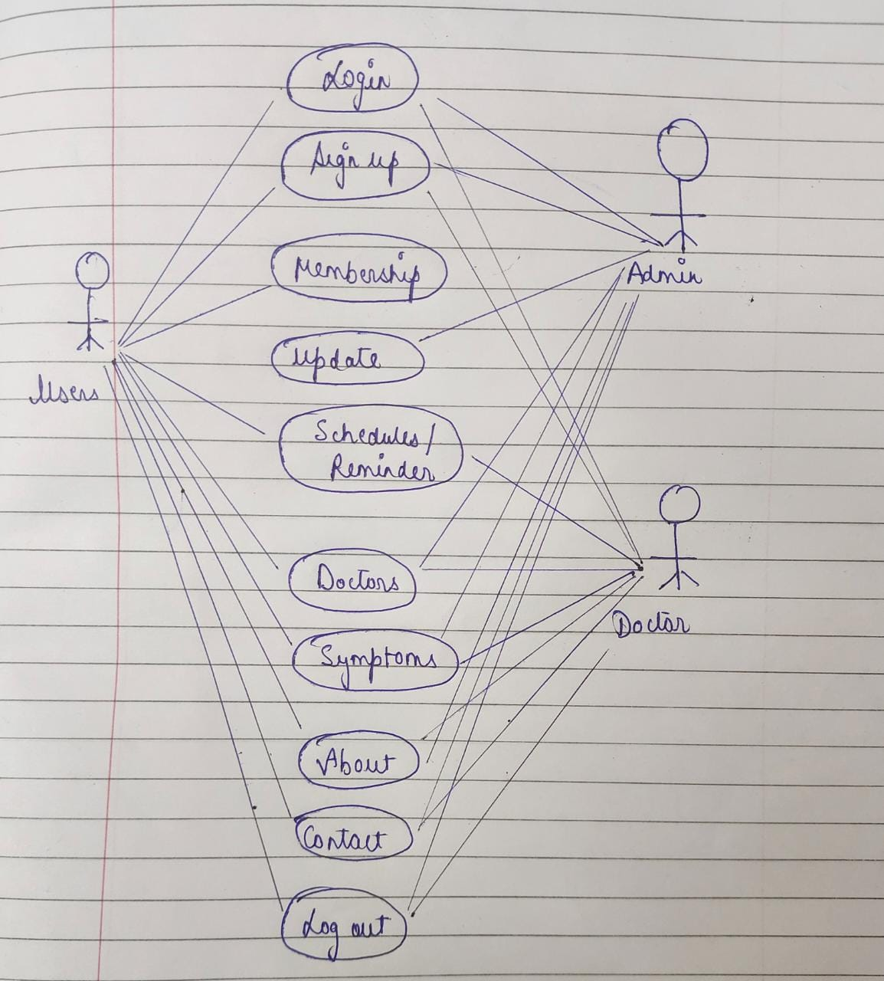**:**

**3.2 PROTOTYPE**

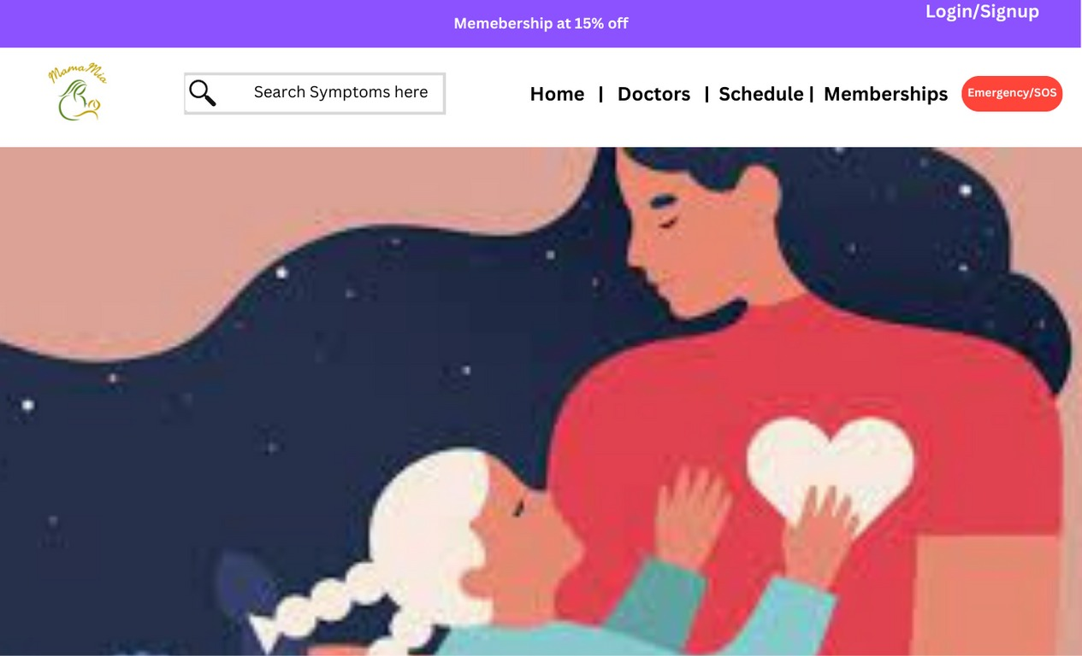

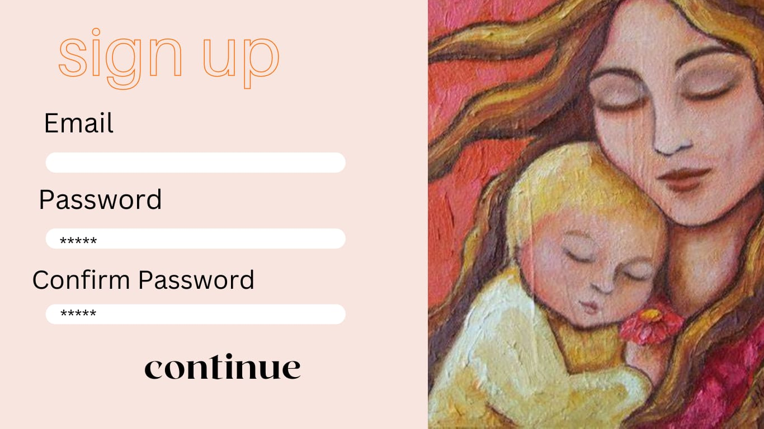

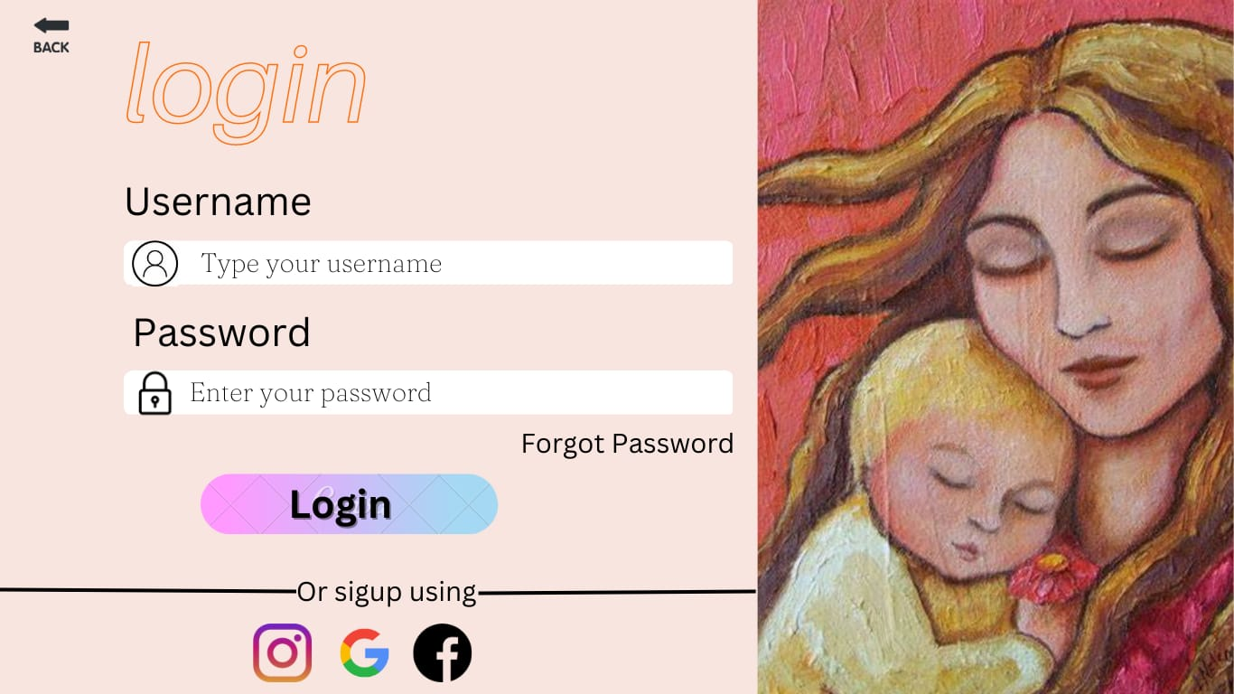

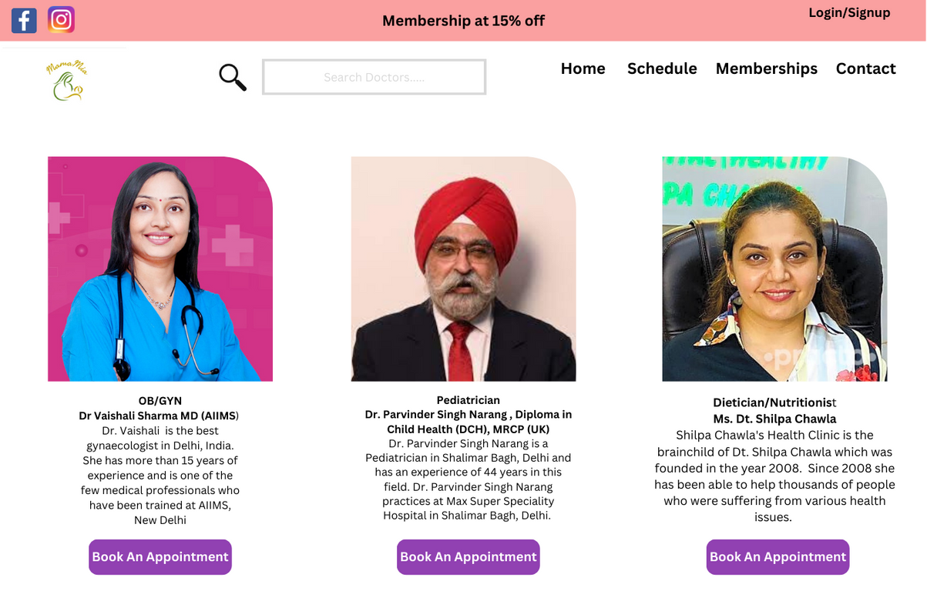

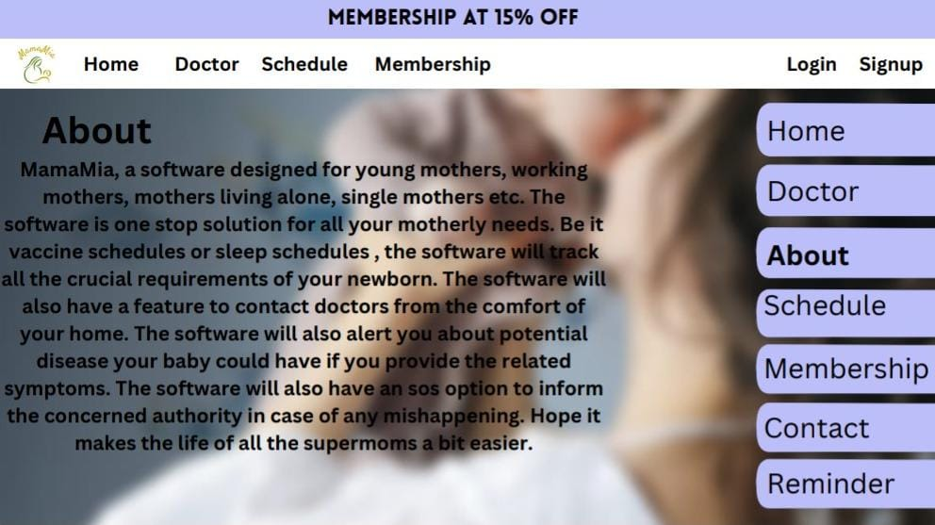

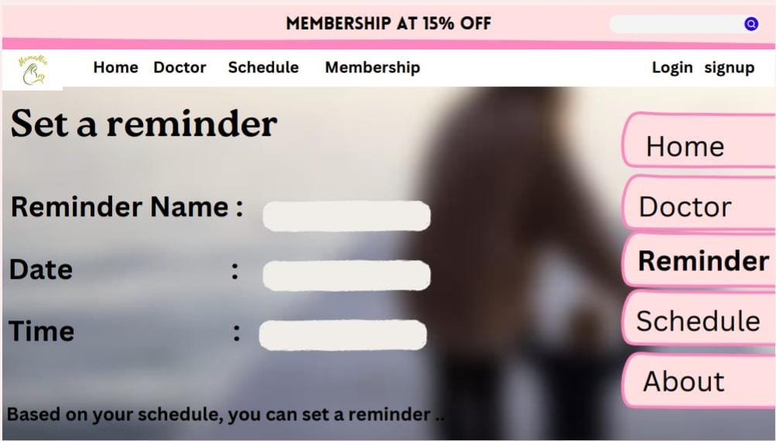

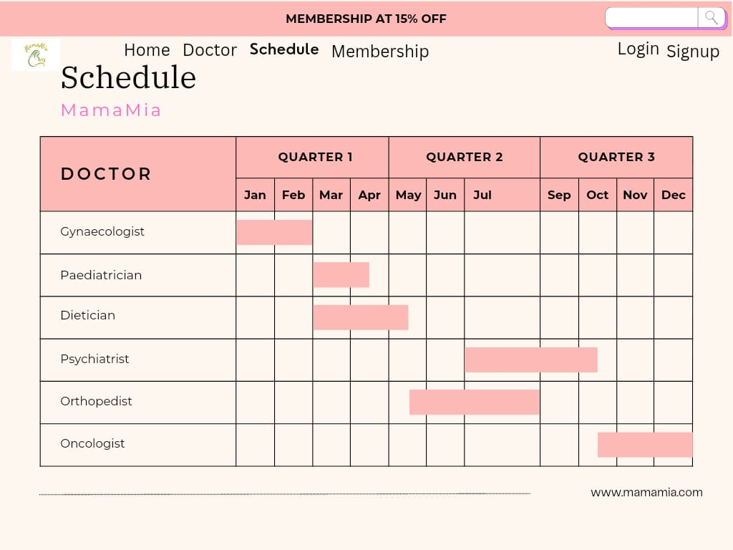



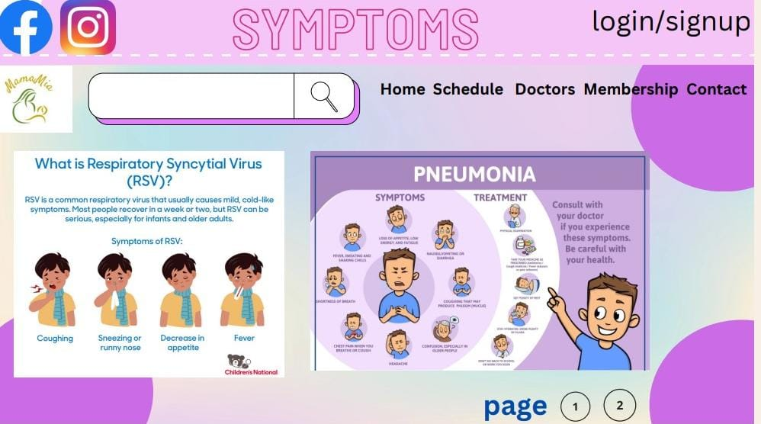

**3.3 DATA FLOW DIAGRAM:**

**3.3.1 Context Level Diagram**

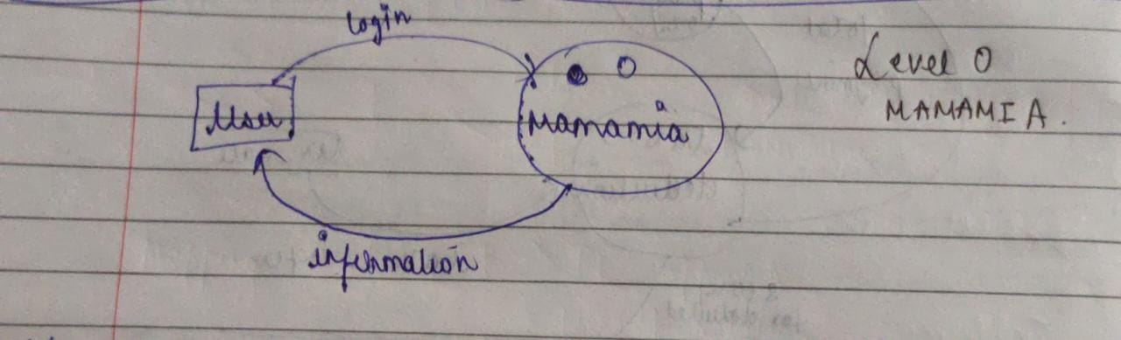

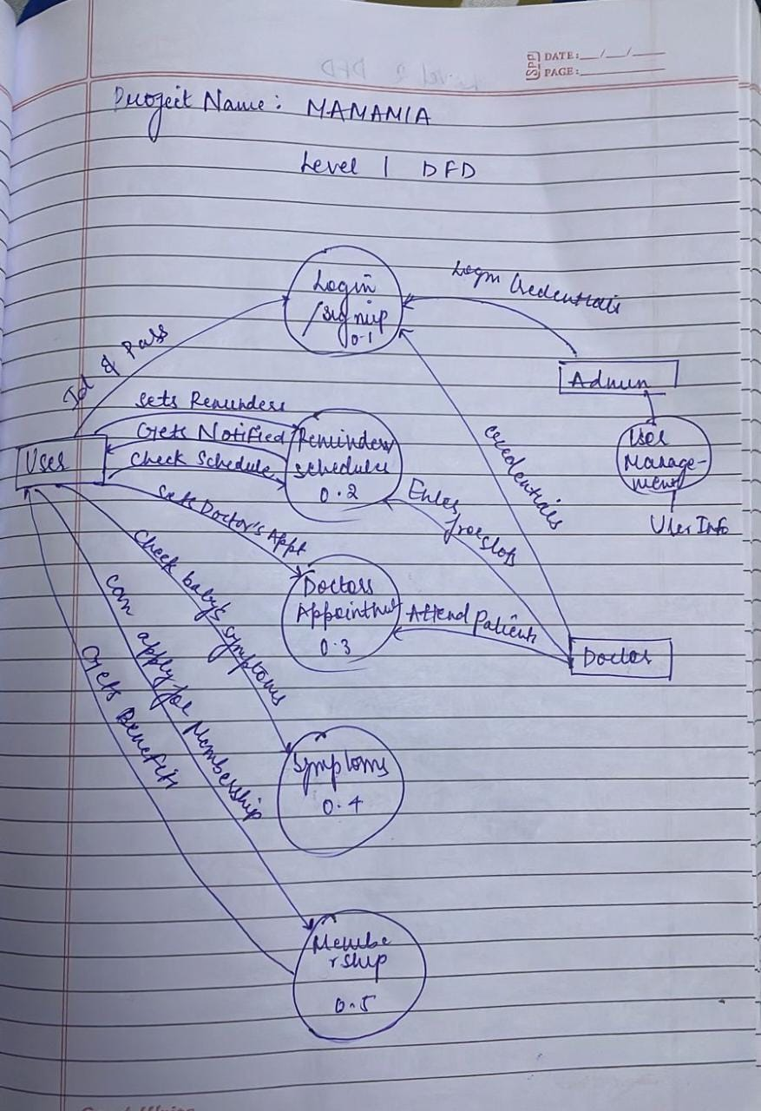

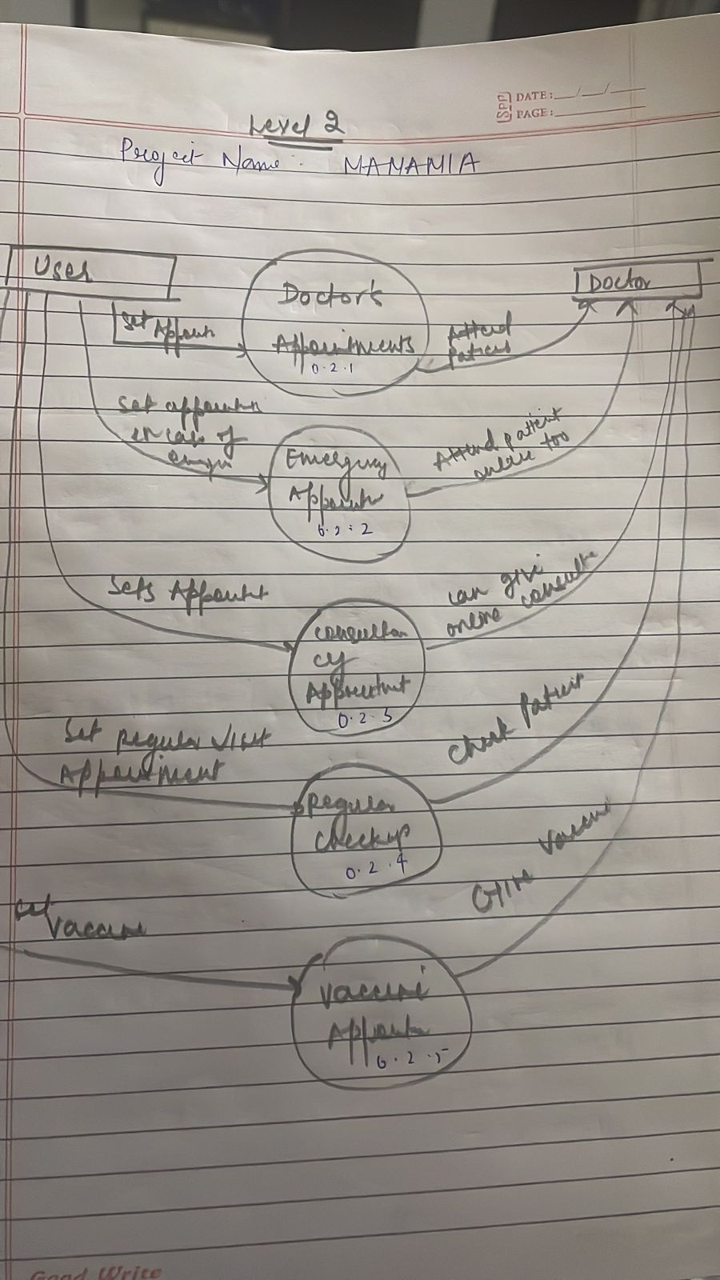

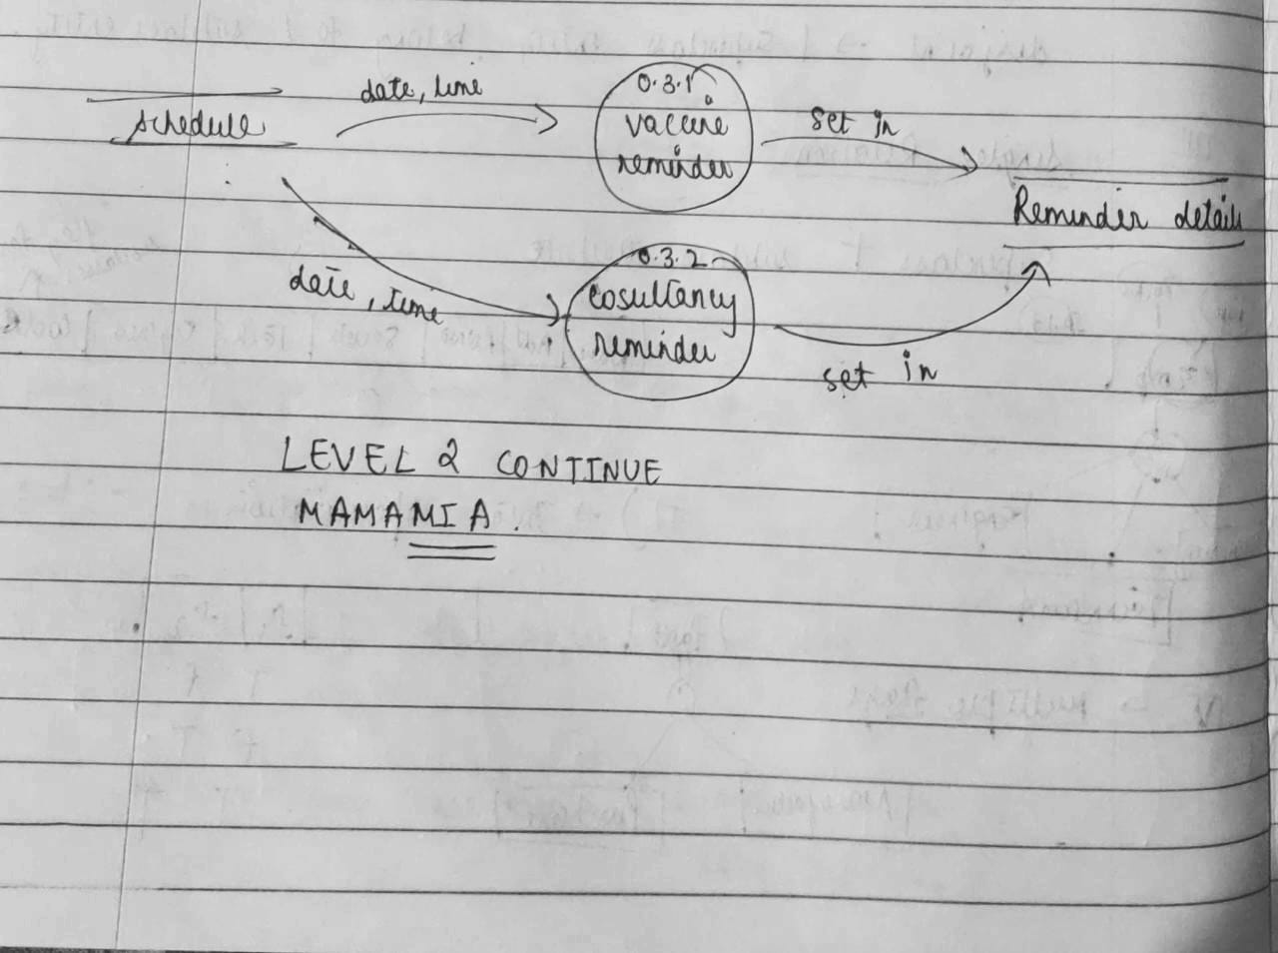

**3.4** DATA DICTIONARY

Legal Characters : [a-z | A-Z]

Digits :[0-9]

Special Characters: [, | - | @ |# |$| . ]

|  |  |
| --- | --- |
| Name | {legal Characters}* |
| Username | {Legal Characters + Special Characters + Digits}* |
| Email ID | {Legal Characters + Special Characters + Digits}* |
| Password | {Legal Characters + Special Characters + Digits}* |
| DOB | {Legal Characters + Digits}* |
| Phone No | {Digits}* |
| Appointment Schedule | {Legal Characters + Digits}* |
| Membership Payment | { Digits}* |
| Membership Transaction Details | {Legal Characters + Special Characters + Digits}* |
| Symptoms Query | {Legal Characters}* |

**3.6 DATA DESIGN TABLE**

|  |  |  |  |  |  |
| --- | --- | --- | --- | --- | --- |
| **Field name** | **Type** | **Specification** | **Constraint** | **Unique** | **Description** |
| Name | String | 30 alphanumeric characters | Not null | Yes | Name of the user. |
| Age | Integer | 2 digit | Not null | Yes | Age of the user |
| Contact number | Integer | 10 digit | Not null | Yes | Contact number of the user. |
| Email | alphanumeric | 40 alphanumeric characters | Not null | Yes | Email address of the user. |
| Address | Alphanumeric | 50 alphanumeric characters | Not null | Yes | Email address of the user. |

**USER INFO(SIGNUP) TABLE:**

|  |  |  |  |  |  |
| --- | --- | --- | --- | --- | --- |
| **Field name** | **Type** | **Specification** | **Constraint** | **Unique** | **Description** |
| Name | String | 30 alphanumeric characters | Not null | Yes | Name of the user’s child |
| Age | integer | 2 | Not null | No | Age of the user’s child. |
| Birth date | date | YY-MM-DD | Not null | Yes | Birth date of child. |

**CHILD INFO TABLE:**

**LOGIN INFO TABLE:**

|  |  |  |  |  |  |
| --- | --- | --- | --- | --- | --- |
| **Field name** | **Type** | **Specification** | **Constraint** | **Unique** | **Description** |
| User id | alphanumeric | 40 alphanumeric characters. | Not null | yes | User id(i.e email) of the user. |
| Password | alphanumeric | 15 alphanumeric characters | Not null | yes | Password for login into mamamia. |

**REMINDER INFO TABLE:**

|  |  |  |  |  |  |
| --- | --- | --- | --- | --- | --- |
| **Field name** | **Type** | **Specification** | **Constraint** | **Unique** | **Description** |
| Reminder name | String | 15 alphanumeric characters | Not null | no | Name of the reminder. |
| Time | time | Hours-min-sec | Not null | no | Time at which user want to have reminder. |

PATIENT CONTACT DETAILS TABLE:

|  |  |  |  |  |  |
| --- | --- | --- | --- | --- | --- |
| **Field Table** | **Type** | **Specialization** | **Constraint** | **Unique** | **Description** |
| Name | String | 30 Alphanumeric characters | Not Null | Yes | Name of the patient |
| Email ID | Alphanumeric | 40 Alphanumeric characters | Not Null | Yes | Email ID of patient |
| Phone No. | Integer | 10 digit | Not Null | Yes | Phone no. of patient |
| Alternative Phone No. | Integer | 10 digit | Optional | Yes | Any phone no. other than above to contact the patient |
| Address | Alphanumeric | 50 Alphanumeric characters | Optional | Yes | Address of patient |
| Age | Integer | 2 digit | Not Null | No | Age of patient |

**DOCTOR INFO TABLE:**

|  |  |  |  |  |  |
| --- | --- | --- | --- | --- | --- |
| **FIELD NAME** | **TYPE** | **SPECIFICATION** | **CONSTRAIN** | **UNIQUE** | **DESCRIPTION** |
| Name | String | 30 alphanumeric characters | Not null | Yes | Name of the Doctor |
| Contact No. | Integer | 10 digit | Not null | Yes | Contact number of Doctor |
| Email | Alphanumeric | 40 alphanumeric characters | Not null | Yes | Email address of the Doctor |
| Age | Integer | 2 | Not null | No | Age of Doctor |
| Specialization | String | 50 alphanumeric characters | Not null | Yes | Field where they are specialized |
| Address | Alphanumeric | 50 alphanumeric characters | Not null | Yes | Address of the clinic of Doctor. |
| Experience | Alphanumeric | 150 alphanumeric characters | Not null | Yes | Experience in the field. |

SCHEDULE:

|  |  |  |  |  |  |
| --- | --- | --- | --- | --- | --- |
| **FIELD TABLE** | **TYPE** | **SPECIFICATION** | **CONSTRAIN** | **UNIQUE** | **DESCRIPTION** |
| Name of patient | String | 30 alphanumeric characters | Not null | Yes | Name of the Patient |
| Contact No. of user | Integer | 10 digit | Not null | Yes | Contact number of user |
| Email id of user | Alphanumeric | 40 alphanumeric characters | Not null | Yes | Email address of the Patient |
| Age | Integer | 2 | Not null | No | Age of Patient |
| Address of Patient | Alphanumeric | 50 alphanumeric characters | Not null | Yes | Address of the clinic of Patient. |
| Name of Doctor | String | 30 alphanumeric characters | Not null | Yes | Name of the Doctor |
| Address of hospital | Alphanumeric | 50 alphanumeric characters | Not null | Yes | Address of the hospital |
| Date of appointment | Date | YY-MM-DD | Not null | Yes | Date for the appointment |
| Start Time of appointment | Time | HH:MM:SS | Not null | Yes | Start Time of the appointment |
| End Time of appointment | Time | H:MM:SS | Not null | Yes | End time of appointment |
| First consultation Fee | Integer | 4 digit | Not null | Yes | Fee charged by the Doctor for an initial visit |

MEMBERSHIP:

|  |  |  |  |  |  |
| --- | --- | --- | --- | --- | --- |
| Payment Details | | | | | |
| **Field Table** | **Type** | **Specialization** | **Constraint** | **Unique** | **Description** |
| Payment Method | String | 20 Alphanumeric characters | Not Null | Yes | Enter payment method |
| **Payment through UPI** | | | | | |
| UPI ID | Alphanumeric | 50 Alphanumeric characters | Not Null | Yes | Enter your Upi id |
| PIN | Integer | 4 digit | Not Null | Yes | Enter your 4 digit pin |
| **Debit/Credit card** | | | | | |
| Name | String | 20 Alphanumeric character | Not Null | Yes | Enter Cardholder name |
| Card No. | Integer | 16 digit | Not Null | Yes | Enter card no. |
| End Date | Integer | 4 digit | Not Null | Yes | Enter Expiry date of |
| CVV | Integer | 3 digit | Not Null | Yes | Enter cvv no. |

1. **SOFTWARE REQUIREMENTS SPECIFICATION**

**4.1Introduction**

This section gives an overview of all the information and details this document contains. This will give the reader a better understanding of the concept.

**4.1.1 Purpose**

The purpose of this document is to specify the requirements of our project ‘MAMAMIA’. Our Project aims toward creating an easily accessible environments for mothers all around the country. The software will focus towards creating an ecosystem for new mothers, single mothers, working mothers etc. The software will provide reminders and schedule services, doctors, easy symptom detection, online consultancy and many more to the mothers for a better handling of their infant . The user will also get memberships offer. This document will mention every significant detail about the requirements of our project.

**4.1.2 SCOPE**

‘MAMAMIA’ is software that was made to target the audience of mothers of the country. To provide them better healthcare, better facilities is what MAMAMIA looks forward to.

The User will register themselves either as a mother, doctor, or a system administrator. They will provide their credentials and their profile will be created based on the info they provided. If the user is a mother, she will get the facility of vaccine reminders for their baby, upcoming schedules and appointments, 1-1 consultancy with highly experienced doctors, symptoms mapping for their infant etc. The mother will also have the option choose membership provided by the software, where they will get many offers and discounts on doctors visit. If the user is a doctor, they’ll enter their details and have their own profile. The doctor will give online consultancy to a patient in the working hours. They will also answer FAQs asked by mothers frequently.

**4.1.3 DEFINTION, ACRONYM AND ABBREVIATIONS** • HTML- Hyper-Text Mark-up Language

• HTTP – Hyper-Text Transfer Protocol

• TCP/IP – Transmission control Protocol/ Internet Protocol

• PHP - Hypertext Preprocessor

• OTP- One Time Password

**4.1.5 OVERVIEW**

The rest of the SRS document describes various system requirements, interfaces, features and

functionalities in detail**.**

**4.2 THE OVERALL DESCRIPTION**

This section will give an overview of the whole system. This section basically describes the software’s principal functions. The system will be explained in context to show how the system interacts with other systems and the description of this section would cover the system interfaces, hardware and network interfaces, system memory demands and site-specific requirements. It will also describe the type of stakeholders that will use the system and what type of functionalities are available to them. At last, the description with limitations that affect the software’s development will be presented. These constraints might include hardware requirements, reliability plus security elements, auditing requirements, etc.

**4.2.1 PRODUCT PERSPECTIVE**

The “MAMAMIA” is an android-based open-source system with web service in order to

find and hire service providers.

The system involves two end users that are customer (who will receive the service) and the service provider (who will provide the service). The system can be used by anyone who has an android-based system. It provides a portal for customers to find a suitable service provider.

**2.1.1 USER INTERFACE**

User interface must be implemented using any tool or software package like VS code, MS Front Page, etc.

**2.1.2 HARDWARE INTERFACE**

Since the application may run over the internet, all the systems using this application may need to connect with internet and this will be a hardware interface, for example, Modem, WAN, LAN, Ethernet, and Cross-Cable.

**2.1.3 SOFTWARE INTERFACE**

The software is on server so it requires the support of scripting languages like PHP etc. Also to handle a large number of users and user’s related databases the software requires the help of database systems like MySQL, and Firebase. The version of system’s software shall be compatible to the application to make it accessible.

**4.3 SPECIFIC REQUIREMENTS**

**4.3.1 USER INTERFACE**

The user interface for the software shall be compatible to any browser such as Google Chrome, Opera or Mozilla Firefox by which user can access to the system.

The user interface shall be implemented using any tool or software package like HTML, PHP etc**.**

**4.3.2 HARDWARE INTERFACE**

Hardware shall be connected to the internet since the application would run over the internet.

For e.g., Modem, WAN, LAN, Ethernet Cross-Cable. Hardware requirement for the software is a mobile with android based system.

**4.3.3 SOFTWARE INTERFACE**

This includes the embedded software that will be used in supporting the various functions of

the system.

• Operating system- Android

• Firebase or SQL for DBMS database

• Platform- PHP, HTML

**4.3.4 COMMUNICATION INTERFACE**

As communication takes place over the internet, HTTP protocol and TCP/IP protocol suite shall be used for intranet communication for sharing pictures and documents over the application.

**4.4 FUNCTIONS**

Software provides the following functionalities: -

• Register

The user will have to register themselves by setting a username and password. Along with this, the user is supposed to enter their phone number which will be used for OTP authentication.

There are two different types of users: -

1. Doctor - User has to provide details about their name, age, specialties, state, district, achievements and available working slots.

2. Patient/Receiver of service- User has to provide just the basic details of registration.

After this, an account will be created of the respective user with their details**.**

**• Login**

The user will have to enter their username and password to login into their account.

In case user forgets their password, they can reset the password after successful OTP authentication. If the user failed to enter the correct OTP an error message will be displayed.

**• Search for Doctors**

1. The Patient can search for required Doctor by choosing the specialist’s name and city.

According to which a directory of related Doctor will be displayed along with

their details which include Doctor’s name, specialties, achievements.

**• Discussion panel and Chat**

The Patient can send a communication request to the Doctor.

1. If Doctor accepts the request, they can discuss about the treatment requirements and the appointment via chat and can also share contacts if required.

2. The request will be declined if the Doctor is not available or if Doctor did not reply within 1 hour. New doctor suggestion will be displayed.

**• Appointment confirmation**

After checking the schedule of doctor appointment will be given to the patient, they can choose the date and time of appointment displayed in the doctor schedule according to their preference.

After confirming the appointment an email of confirmation will be send to both patients and doctor.

**• Project Status**

User can keep track of their appointment or request status which can be any one of the following:

1. Communication Request Accepted

2. Communication Request Declined

3. Communication Request Pending

4. appointment Confirmed

• Notification

A notification will be sent to both the Patient and Doctors as a reminder with the appointment.

• Reviews and Ratings

User can provide their reviews and rate the doctor for their treatment.

**4.5 PERFORMACE REQUIREMENTS**

Response time: - The software shall take initial loading time depending on internet connection strength. When the patient books a appointment, they will get a reply as soon as the Doctor responds.

Throughput: -The number of transactions or tasks is directly dependent on the number of users. The users may be doctor or the patient.

Resource utilization: -The resources are modified according to the user requirements.

**4.6 DESIGN CONSTRAINTS**

• Software languages used

The languages that shall be used for coding the MAMA MIA are

ASP, HTML, CSS and PHP For working on the coding phase of MAMA MIA, the internet information services (IIS) Servers needs to be installed.

**4.7 SOFTWARE SYSTEM ATTRIBUTES**

System attribute requirements such as those for performance, security, modifiability, reliability and usability have a significant influence on the software architecture of a system. There are a number of quality attributes of software that can serve as requirements.

**4.7.1 SAFETY AND SECURITY CONSTRAINTS**

The system shall use a secured database

The system shall be reliable to control the network security breaches

The system shall not leave any cookies on the user’s mobile device.

**4.7.2 USABILITY**

use the application Users with basic smartphone knowledge can easily.

**4.7.3 RELIABILITY**

The backup of the database is continuously maintained and updated to reflect the most recent

changes made by the Doctor (i.e., updating their profile by adding their recent achievements pictures and information) or Patient (i.e., new symptoms or treatment).

**4.7.4 AVAILABILITY**

The system is available all the time to the user as an android application. It will provide real time information about the Doctor, their details and work experiences.

**4.7.5 PORTABILITY**

**“**MAMA MIA” is a portable app which allows user to find and appoint a doctor by their respective systems. All the necessary data can be accessed by anyone with android based system.

**SEQUENCE DIAGRAM**

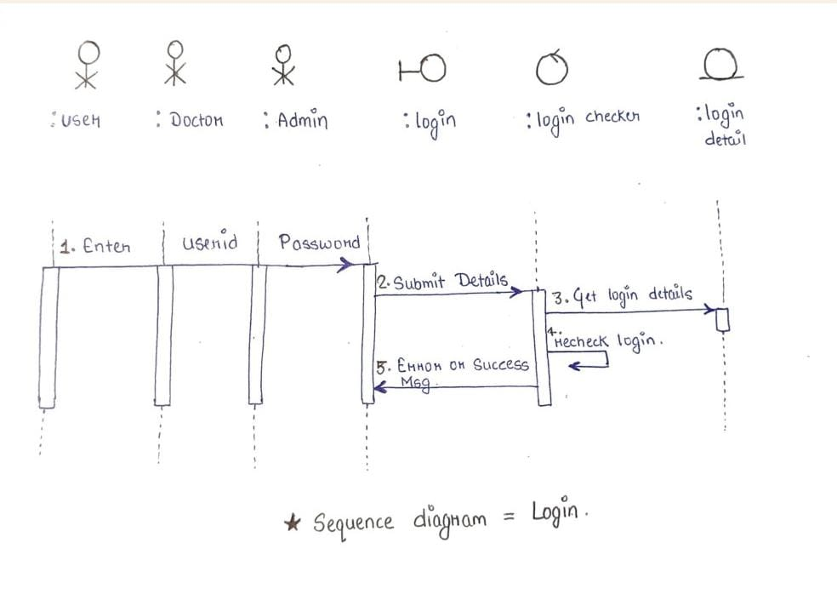

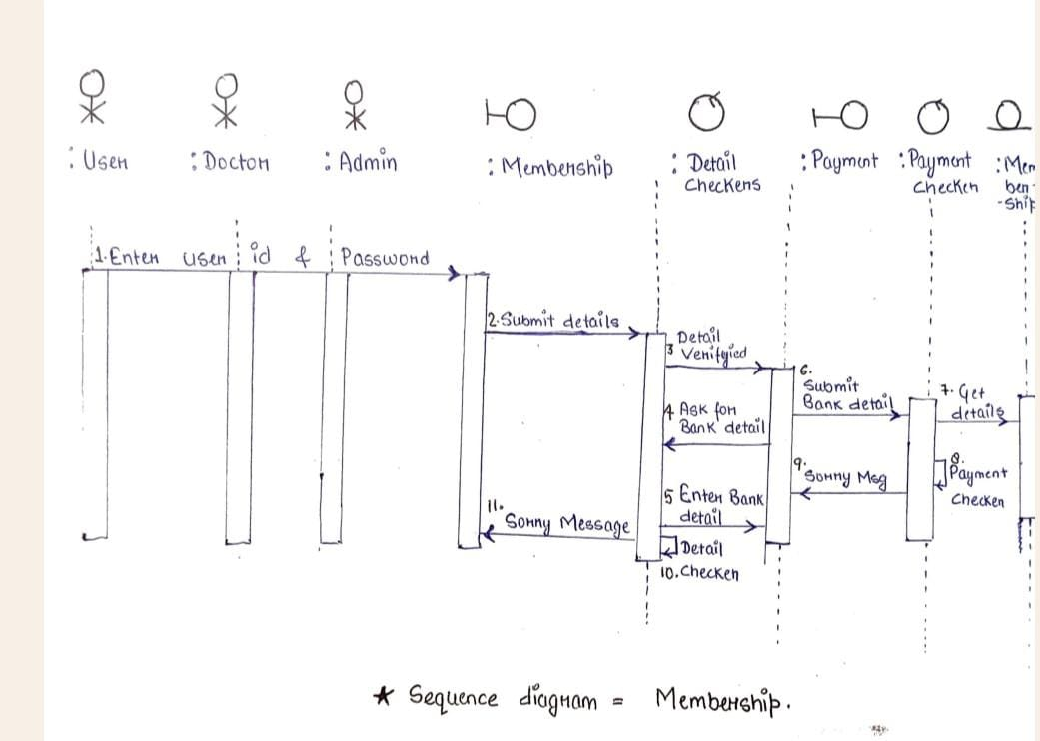

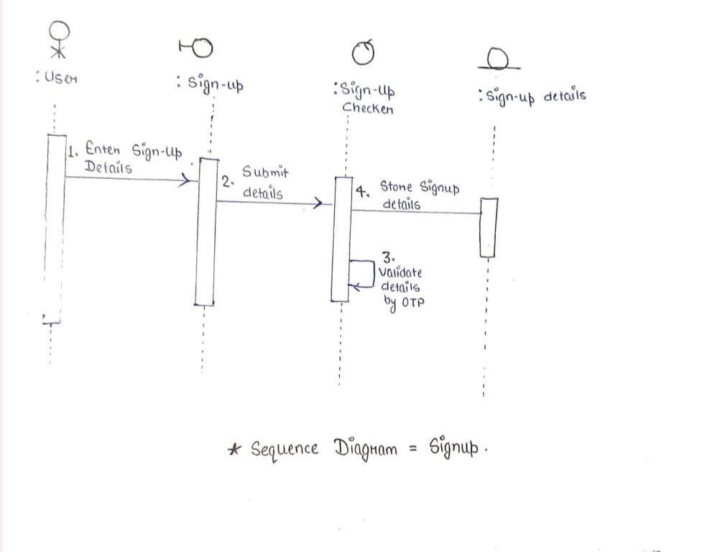

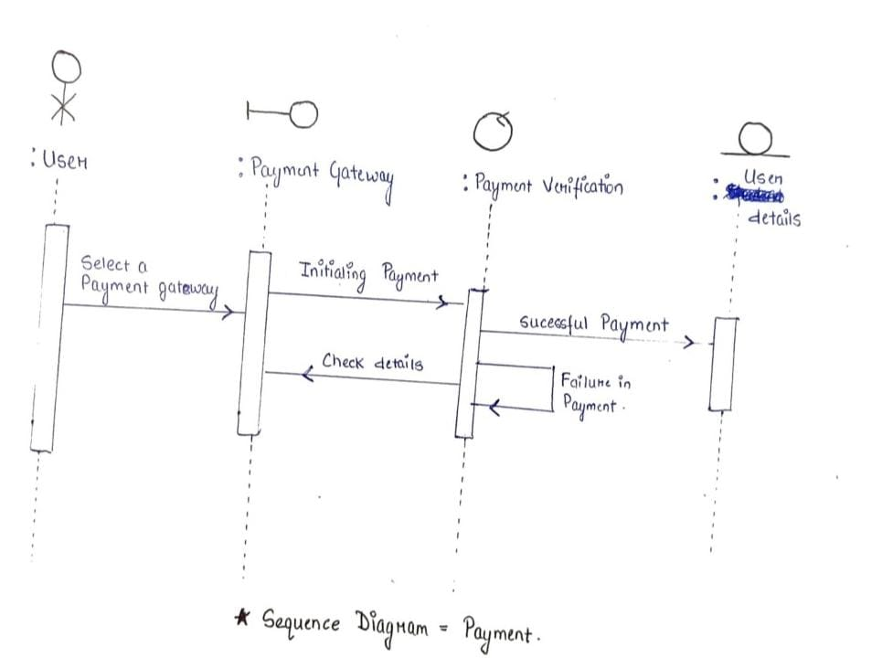

|  |  |  |  |  |  |  |  |  |  |  |  |  |  |  |  |  |
| --- | --- | --- | --- | --- | --- | --- | --- | --- | --- | --- | --- | --- | --- | --- | --- | --- |
| WORK TASK | JANUARY |  |  |  | FEBURARY |  |  |  | MARCH | |  |  |  | APRIL |  |  |
|  | W1 | W2 | W3 | W4 | W1 | W2 | W3 | W4 | W1 | W2 | | W3 | W4 | W1 | W2 | W3 |
| PROBLEM STATEMENT |  |  |  |  |  |  |  |  |  |  | |  |  |  |  |  |
| PROJECT SCHEDULING |  |  |  |  |  |  |  |  |  |  | |  |  |  |  |  |
| TIMELINE CHART |  |  |  |  |  |  |  |  |  |  | |  |  |  |  |  |
| CONTEXT LEVEL DIAGRAM |  |  |  |  |  |  |  |  |  |  | |  |  |  |  |  |
| DFD LEVEL-1 |  |  |  |  |  |  |  |  |  |  | |  |  |  |  |  |
| DFD LEVEL-2 |  |  |  |  |  |  |  |  |  |  | |  |  |  |  |  |
| DATA DICTIONARY |  |  |  |  |  |  |  |  |  |  | |  |  |  |  |  |
| USECASE DIAGRAM |  |  |  |  |  |  |  |  |  |  | |  |  |  |  |  |
| USECASE DESCRIPTION |  |  |  |  |  |  |  |  |  |  | |  |  |  |  |  |
| PROTOTYPE  DESIGNING |  |  |  |  |  |  |  |  |  |  | |  |  |  |  |  |
| DATA DESIGN TABLE AND DICTIONARY |  |  |  |  |  |  |  |  |  |  | |  |  |  |  |  |
| SRS |  |  |  |  |  |  |  |  |  |  | |  |  |  |  |  |
| PROJECT METRICS |  |  |  |  |  |  |  |  |  |  | |  |  |  |  |  |
| EFFORT ESTIAMTION |  |  |  |  |  |  |  |  |  |  | |  |  |  |  |  |
| RISK ANALYSIS |  |  |  |  |  |  |  |  |  |  | |  |  |  |  |  |
| DESIGN |  |  |  |  |  |  |  |  |  |  | |  |  |  |  |  |
| TESTING |  |  |  |  |  |  |  |  |  |  | |  |  |  |  |  |

**PROJECT SCHEDULING**

|  |  |  |  |  |  |  |
| --- | --- | --- | --- | --- | --- | --- |
| WORD TASKS | PLANNED  START | ACTUAL START | PLANNED COMPLETE | ACTUAL COMPLETE | ASSIGNED  PERSON(s) | EFFORT ALLOCATED |
| PROBLEM  STATEMENT | January, w1 | January, w1 | January, w2 | January, w2 | Bhoomi priya | 1 person  Per week |
| SOFTWARE  LIFECYCLE MODEL | January, w1 | January, w1 | January, w1 | January, w1 | Bhoomi,  Divya,  Ravina,  Srishti,  Tanya | 5 person  Per week |
| PROJECT  SCHEDULING | January, w3 | January, w3 | January, w3 | January, w3 | Divya | 1 person  Per week |
| TIMELINE  CHART | January, w3 | January, w3 | January, w3 | January, w3 | Srishti | 1 person  Per week |
| CONTEXT LEVEL  DIAGRAM | February, w1 | February, w1 | February, w1 | February, w1 | Bhoomi,  Divya, Ravina | 3 person  Per week |
| DFD LEVEL-1 | February, w2 | February, w2 | February, w2 | February, w2 | Srishti, Tanya | 2 person  Per week |
| DFD LEVEL-2 | February, w2 | February, w2 | February, w3 | February, w3 | Divya,  Bhoomi,  Ravina | 3 person  Per week |
| DATA DICTIONARY | February, w3 | February, w4 | February, w3 | February, w4 | Srishti,  Tanya | 2 person  Per week |
| USE CASE  DIAGRAM | February, w4 | March, w1 | March, w1 | March, w3 | Srishti | 1 person  Per week |
| PROTOTYPE  DESIGNING | February,  w3 | February,  W3 | Febrauary,  W4 | Febraury,  W4 | Bhoomi,  Divya, Ravina,  Srishti,  Tanya | 5 person  Per week |
| USE CASE  DESCRIPTION | February, w4 | March, w1 | March, w2 | March, w2 | Bhoomi,  Divya, Ravina,  Srishti,  Tanya | 5 person  Per week |
| SRS | March,w1 | March,w1 | March,w2 | March,w3 | Bhoomi,  Divya, Ravina | 3 person  Per week |
| PROJECT METRICS | March, w1 | March, w3 | March, w2 | March, w4 | Bhoomi,  Divya, Ravina,  Srishti,  Tanya | 5 person  Per week |
| EFFORT  ESTIMATION  (COCOMO ) |  |  |  |  |  |  |
| RISK ANALYSIS |  |  |  |  |  |  |
| DESIGN |  |  |  |  |  |  |
| TESTING |  |  |  |  |  |  |

1. **FUNCTION POINT METRICS**



**Number of external Inputs: 1**

**Number of External Outputs: 1**

**Number of External Inquiries:1**

**Number of Internal Logical Files: 1**

**Number of External Interfaces: 0**



**Number of External Input: 3**

**Number of External Output: 1**

**Number of External Inquiries: 0**

**Number of Internal Logical Files: 1**

**Number of External Interfaces: 0**



**Number of External Input: 2**

**Number of External Output: 1**

**Number of External Inquiries: 0**

**Number of Internal Logical Files: 1**

**Number of External Interfaces: 0**



**Number of external Inputs: 2**

**Number of External Outputs: 2**

**Number of External Inquiries:1**

**Number of Internal Logical Files: 1**

**Number of External Interfaces: 0**



**Number of External Inputs :0**

**Number of External Outputs :0**

**Number of External Inquiries :0**

**Number of Internal Logical Files :0**

**Number of External Interfaces :0**



**Number of External Inputs :3**

**Number of External Outputs :1**

**Number of External Inquiries :0**

**Number of Internal Logical Files :0**

**Number of External Interfaces :0**



**Number of External Input: 0**

**Number of External Output: 1**

**Number of External Inquiries: 0**

**Number of Internal Logical Files: 1**

**Number of External Interfaces: 0**



**Number of External Input: 0**

**Number of External Output: 1**

**Number of External Inquiries: 0**

**Number of Internal Logical Files: 1**

**Number of External Interfaces: 0**

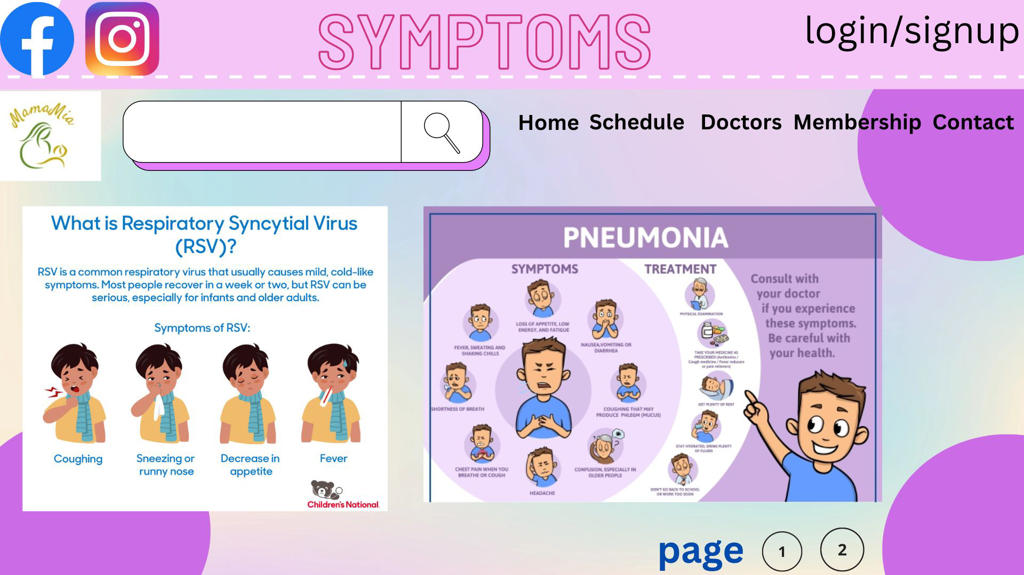

**Number of External Inputs:0**

**Number of External Outputs: 1**

**Number of External Inquiries: 1**

**Number of Internal Logical Files: 1**

**Number of External Interfaces: 0**

**FUNCTION – POINT METRIC**

The function point (FP) metric can be used effectively as a means for measuring the

Functionality delivered by a system. Using historical data, the FP metric can be used to:

(1). Estimate the cost or effort required to design, code, and test the software.

(2). Predict the number of errors that will be encountered during testing.

(3). Forecast the number of components and/or the number of projected source lines in the

Implemented system.

Function points are derived using an empirical relationship based on countable (direct)

Measures of software’s information domain and qualitative assessments of software Complexity.

Information domain values are defined as:

i).Number of external inputs (EIs): Each external input originates from a user or is transmitted from another application and provides distinct application-oriented data or control information. Inputs are often used to update internal logical files (ILFs).

ii).Number of external outputs (Eos): Each external output is derived data within the application that provides information to the user. In this context external output refers to reports, screens, error messages, and the like.

iii).Number of external inquiries (EQs): An external inquiry is defined as an online input that results in the generation of some immediate software response in the form of an online output (often retrieved from an Internal Logical File).

iv).Number of internal logical files (ILFs): Each internal logical file is a logical grouping of data that resides within the application’s boundary and is maintained via external inputs

v).Number of external interface files (EIFs): Each external interface file is a logical grouping of data that resides external to the application but provides data that may be of use to the application.

The Fi ( I = 1 to 14) are value adjustment factors (VAF) based on responses to the following Questions:

1. Does the system require reliable backup and recovery?

**5**

1. Are specialized data communications required to transfer information to or from the Application?

3

1. Are there distributed processing functions?

4

1. Is performance critical?

3

1. Will the system run in an existing, heavily utilized operational environment?

2

1. Does the system require online data entry?

5

1. Does the online data entry require the input transaction to be built over multiple screens or Operations?

4

1. Are the ILFs updated online?

5

1. Are the inputs, outputs, files, or inquiries complex?

1

1. Is the internal processing complex?

3

1. Is the code designed to be reusable?

0

1. Are conversion and installation included in the design?

3

1. Is the system designed for multiple installations in different organizations?

1

1. Is the application designed to facilitate change and ease of use by the user?

4

TOTAL = 43

FP = count total × [0.65 + (0.01 × Σ( Fi ))]

Where count total is the sum of all FP entries obtained from the table given below.

|  |  |  |  |  |  |  |  |
| --- | --- | --- | --- | --- | --- | --- | --- |
| **Information Domain**  **Value** | **Count** |  | **Weighting Factor** | | |  |  |
|  |  |  | **Simple** | **Average** | **Complex** |  |  |
| **External Inputs** | 11 | × | 3 | 4 | 6 | = | 33 |
| **External Outputs** | 9 | × | 4 | 5 | 7 | = | 36 |
| **External Inquiries** | 3 | × | 3 | 4 | 6 | = | 9 |
| **Internal Logical Files** | 7 | × | 7 | 10 | 15 | = | 49 |
| **External Interface Files** | 0 | × | 5 | 7 | 10 | = | 0 |
| **Count Total** |  |  |  |  |  | = | 127 |

In our project there are, we have the weighting factor as simple for all the five information

domain values.

W(FP)= count total × [0.65 + (0.01 × ∑(Fi))]

= 127 × [0.65 + (0.01 × 43)] = 127× 1.08

= 137.16 FP

Let

Average Productivity = X = 4 FP/pm

Labour rate = Y =Rs 8000 person per month

So,

Cost per FP = Z = Y/X = Rs 8000/4 = Rs 2000(approx.)

Total estimated project cost = W*Z = Rs 2,74,320 (approx.)

1. EFFORT ESTIMATION USING COCOMO II MODEL

The Constructive Cost Model (COCOMO II) is a more comprehensive estimation model. It is

the model that allows one to estimate the cost, effort and schedule when planning a new

software development activity. COCOMO II is actually a hierarchy of estimation models that

address different “stages” of the software process.

1. Stage-I:

It supports estimation of prototyping. For this it uses Application Composition

Estimation Model. This model is used for the prototyping stage of application generator

and system integration.

2. Stage-II:

It supports estimation in the early design stage of the project, when we less know about it.

For this it uses Early Design Estimation Model. This model is used in early design stage

of application generators, infrastructure, and system integration.

3. Stage-III:

It supports estimation in the post architecture stage of a project. For this it uses Post

Architecture Estimation Model. This model is used after the completion of the detailed

architecture of application generator, infrastructure, and system integration.

The COCOMO II models require sizing information. Three different sizing options are

available as part of the model hierarchy:

1. Object points

2. Function points

3. Lines of source code.

The object point is an indirect software measure that is computed using counts of the number

of

(i) screens (at the user interface)

(ii) Reports

(iii) Components likely to be required to build the application

Each object instance (e.g., a screen or report) is classified into one of three complexity levels

(i.e., simple, medium, or difficult). Once complexity is determined, the number of screens,

reports, and components are weighted according to the table.

|  |  |  |  |
| --- | --- | --- | --- |
| OBJECT TYPE | COMPLEXITY WEIGHT |  |  |
|  | SIMPLE | MEDIUM | DIFFICULT |
| SCREEN | 5 | 8 | 7 |
| REPORT | 2 | 2 | 1 |
| 3GL COMPONENT |  |  | 4 |

Figure 5: Complexity Weighing For Object Points

The object point count is then determined by multiplying the original number of object

instances by the weighting factor in the figure and summing to obtain a total object point

count.

When component-based development or general software reuse is to be applied, the percent

of reuse (%reuse) is estimated and the object point count is adjusted:

NOP = (object points) x [(100 - %reuse)/100]

where NOP is defined as new object points.

To derive an estimate of effort based on the computed NOP value, a “productivity rate” must

be derived: -

PROD = NOP/(person−month)

Productivity rate for different levels of developer experience and development environment

maturity: -

|  |  |  |  |  |  |
| --- | --- | --- | --- | --- | --- |
| Developer’s experience | Very low | low | Nominal | High | Very High |
| Environment maturity | Very low | Low | Nominal | High | Very High |
| PROD | 4 | 7 | 13 | 25 | 50 |

Figure 6: Productivity Rate For Object Points

Once the productivity rate has been determined, an estimate of project effort is computed

using

Estimated effort = NOP/PROD

COCOMO ESTIMATION FOR OUR PROJECT

Number of screens = 20

Number of reports = 5

Number of 3GL components used = 4

In our project there are simple screens and reports.gl components-10)

Assumed average complexity(screen-2, reports-5, 3

So, object points = summation of(number of object instances * complexity weight of each instance)

Object point= [(20*2)+(5*5)=(4*10)]

= 40+25+40

=108

Since we are not reusing any of the components in our project, the % reuse is zero here.

NOP = 85 x [(100-0)/100] = 85

PROD = 4

Estimated effort = NOP/PROD

108/4

= 27 person-month.

1. **RISK ANALYSIS**SOFTWARE RISKS:

It involves 2 aspects: uncertainty and loss. Uncertainty means risk may or may not happen. If risk becomes reality, then unwanted consequences or loss will occur.

* PHASES INVOLVED IN RISK ANALYSIS AND MANAGEMENT

1. Risk Identification

2. Risk Analysis

3. Risk Ranking and assessment

4. Creating risk plan or RMMM plan

* TYPES OF RISKS

According to general categorization there are 3 types of risks:

1. Known Risk

2. Predictable Risk

3. Unpredictable Risk

Another category of risk type:

1. Project Risk
2. Technical Risk
3. Business Risk

* **Project Risk:** Identify potential problems that might occur in budget, schedule and staffing. It also includes project complexity, project size and degree of structural uncertainty.
* **Technical Risk:** Identify potential design problem, implementation problem, interface problems, verification

problem and maintenance problem. They threaten the quality of the software produced.

* **Business Risk:** Threatens the viability of the software to be built and often jeopardize the project or the product. There are 5 types of business risks:

1. Market risk
2. Strategic risk
3. Sales risk
4. Management risk
5. Budget risk

# ASSESSING OVERALL PROJECT RISK

1. Have top software and customer mangers formally committed to support the project? **YES**
2. Are end users enthusiastically committed to the project and the system / product to be built? **YES**
3. Are requirements fully understood by the software engineering team and its customers? **YES**
4. Have customers been involved fully in the definition of requirements? **YES**
5. Do end users have realistic expectations? **YES**
6. Is the project scope stable? **YES**
7. Does the software engineering team have the right mix of skills? **YES**
8. Are project requirements stable? **YES**
9. Does the project team have experience with the technology to be implemented? **YES**

**10.** Is the number of people on the project team adequate to do the job? **YES**

**11.** Do all user constituencies agree on the importance of the project and on the requirements for the system/product to be built? **YES**

# Risk Projection

# Risk projection, also called risk estimation, attempts to rate each risk in two ways—

1. The likelihood or probability that the risk is real and will occur and
2. The consequences of the problems associated with the risk, should it occur.

* Four risk projection steps are:

1. Establish a scale that reflects the perceived likelihood of a risk.
2. Delineate the consequences of the risk.
3. Estimate the impact of the risk on the project and the product.
4. Assess the overall accuracy of the risk projection so that there will be no misunderstandings.

# RISK TABLE FOR THE PROJECT

|  |  |  |  |
| --- | --- | --- | --- |
| **RISKS** | **CATEGORY** | **PROBABILITY** | **IMPACT** |
| Size estimate may be significantly  low. | PS | 15% | 2 |
| Large number of users than  planned | PS | 11% | 2 |
| Less reuse than  planned | PS | 35% | 3 |
| End user may  resist the system | BU | 30% | 2 |
| Delivery decline  will be tightened | BU | 25% | 2 |
| Funding will be  lost | CU | 25% | 1 |
| Customer will change  requirements | PS | 20% | 3 |
| Technology will not meet the  expectation | TE | 15% | 2 |
| Lack of training on  tools | DE | 30% | 2 |
| Self in-  experienced | ST | 45% | 3 |
| Staff turnover will  be high | ST | 4% | 2 |
|  |  |  |  |

* **Impact Values:**

1. Catastrophic
2. Critical
3. Marginal
4. Negligible

|  |  |  |  |
| --- | --- | --- | --- |
| **RISKS** | **CATEGORY** | **PROBABILITY** | **IMPACT** |
| Size estimate may be significantly  low. | PS | 15% | 2 |
| Large number of users than  planned | PS | 11% | 2 |
| Less reuse than  planned | PS | 35% | 3 |
| End user may  resist the system | BU | 30% | 2 |
| Delivery decline  will be tightened | BU | 25% | 2 |
| Funding will be  lost | CU | 25% | 1 |
| Customer will change  requirements | PS | 20% | 3 |
| Technology will not meet the  expectation | TE | 15% | 2 |
| Lack of training on  tools | DE | 30% | 2 |
| Self in-  experienced | ST | 45% | 3 |
| Staff turnover will  be high | ST | 4% | 2 |

* **Impact Values:**

1. Catastrophic
2. Critical
3. Marginal
4. Negligible

1. First the person should signup to the website and fill necessary information

9. TESTING

1. //when signup is successful, he/she can login now
2. If( login is successful) then
3. Doctor acsess(gynecologist/ peditrician/ )
4. Person can set a Remainder
5. Can Schedule a appointment
6. Seach for symptoms
7. If( person is paying for membership)
8. He/she can access the benefits of membership
9. Endif(line 7)
10. Endif(3 line)
11. Else
12. Person can search for disease through symptoms
13. End else(line 12)

Procedure ends



**2**

**CONTROL FLOW DIAGRAM**

**3**

**12**

**13**

**14**

**15**

**11**

**8**

**9**

**10**

**7**

**6**

**5**

**4**

* **CYCLOMATIC COMPLEXITY OF RESULTANT GRAPH**

**CC=Total Number Of Regions**

**= 3**

**CC=Number of edges – Number of nodes + 2p**

**= 16 – 15 + 2(1)**

**= 3**

**CC=Number of predicate nodes + 1**

**= 2 + 1**

**= 3**

* **INDEPENDENT BASIC PATHS FROM THE GRAPH**

**Path 1:** 1 -> 2 -> 3 -> 4 -> 5 -> 6 -> 7 -> 8 -> 9 -> 10 -> 11 -> 15

**Path 2:** 1 -> 2 -> 12 -> 13 -> 14 -> 15

**Path 3:** 1 -> 2 -> 3 -> 4 -> 5 -> 6 -> 7 -> 11 -> 15